RESPONSIVE REPAIRS SCRUTINY REPORT
February 2015

A word from The Chair of Riverside Mersey South Scrutiny Panel
The Riverside Mersey South Scrutiny Panel is happy to present our report on Responsive Repairs. Our role was to look at the service offered to tenants and produce thorough, constructive evidence with recommendations that will make a difference to all Riverside tenants. This report is our third scrutiny review. Responsive Repairs are the day to day repairs reported by tenants which do not come under First Time Fix repairs. This is a key service which tenants judge the quality and response they get from Riverside; therefore we decided this was a service that we needed to scrutinise as tenant representatives and as rent payers.
During the scrutiny we interviewed Tenants and both Riverside and Evolve staff and we would like to thank all those who participated in interviews and completed surveys. Although we are still finding some barriers and tensions with staff across particular facets of our evidence gathering and our roles; we have had a good measured response to the review process. The report will be presented to the Riverside Tenant Board and the National Scrutiny Committee where our recommendations will hopefully be taken forward. We hope Staff and Tenants find our report both useful and practical.
Summary
The review found that overall Tenants were satisfied with the repairs service they received from Riverside Mersey South. Tenants told us that they experienced a level of service which drew many compliments and appreciations, thus in our view reflecting the hard work that goes into the planning and delivery of repairs. However when the service does not run as smoothly as Tenants and RMS staff wish it to do so, there were several issues that the Panel suggest require immediate addressing. We sometimes found a lack of evidence to support staff claims across our review. We also found policy and procedures which were out of date and therefore redundant with regards to new legislation. We also found that cost effective methods and tools were not being utilised to their full potential, for example approaches to data collection and analysis in order to inform service improvements. Through our review it is suggested that we also found evidence inferring the need for a future skills audit across Evolve operatives and contractors if not addressed soon. Repeated appointments, unfinished repair jobs and poor quality of work were issues which we found not only frustrated Tenants and impacted upon schedules but has the potential to increasingly affect future statistical data with regard to complaints. The Panel believe these issues are easily addressed through increased vigilance, review of service delivery and better usage of IT and data collection tools.

Table of Contents
Summary…………………………………………………………………………………………………….……………………1
Table of Figures……………………………………………….……………………………………………………………….3
- Introduction………………………………………………………………………….………………….…………3
- Responsive Repairs Scrutiny Review – The Scope…………………………….………………….3
2.1 Why This Service…………………………………………………………………………………….………4
2.2 How We Worked…………………………………………………………………………………….………4
3. Key Findings…………………………………………………………………………………………….…………5
3.1 Policies and Procedures………………………………………………………………………………..…5
4. Tenants Survey……………………………………………………………………………..…..………………..5
4.1 STAR & Tenant Satisfaction Questionnaire………………………………………………………5
4.2 Tenant Interviews…………….…………………………………………………………………………….5
4.3 Panel Tenants Survey………………………………………………………………………………………6
4.3.1 Panel Tenants Survey Data……………………………………………………………………….….7
5. Interviews with RMS staff ………………………………………………………………………………...12
5.1 Personal Digital Assistant Usage and Tracking……….………………………………………12
6. Riverside Mersey South Responsive Repairs Service Complaints……………….………13
7. Equality and Diversity………………………………………………………………………………….……14
7.1 Tailoring Our Service/the Triangle System……………………………………….…………..14
8. Social Value……………………………………………………………………………………………………….14
9. Value for Money……………………………………………………………………………..…………………14
10. Conclusions……………..……………………………………………………………………………………….15
11. Recommendations…………………………………………………………………………………………..16
11.1 Recommendations for National Consideration………………………………………….16
References…………………………………………………………………………………………………………..17
Appendices………………………………………………………………………………………………………….18
Table of Figures
Figure 1 Contacting RRS 7
Figure 2. Appointment Times 7
Figure 3. Contractor Updates and Additional Information 9
Figure 4. Post Repair Condition 9
Figure 5. Post Repair Inspection 10
Figure 6. Complaints Frequency by Trade 12

- Introduction
The Scrutiny Panel currently consists of six Riverside tenants from across the Division who responded to a request for volunteers for the new Mersey South Divisional Scrutiny Panel. In 2013 we went through a selection process and were then trained for our role. The role of the panel is to provide robust tenant scrutiny of housing services within the Division, acting as Riverside’s ‘critical friends’. We do this by:
- Maintaining a watching brief on housing management performance and compliance with regulatory standards.
- Scrutinising the effectiveness of the strategies, policies and procedures of Mersey South in comparison to other Divisions across the Riverside Group and other similar Providers
- Identifying issues of concern to tenants and residents and carrying out in depth scrutiny reviews
- Making recommendations to the Division.
The Mersey South Resident Scrutiny Panel will report its findings to the Divisional Board and to other Riverside scrutiny panels.

- Responsive Repairs Service Review – The Scope
The Panel met during the period of October 2014 to February 2015 to review the process of responsive repairs for general needs properties in Riverside Mersey South Division. This report focuses upon facets of the Responsive Repairs Service (RRS) which tenants experience on a day to day basis and not as First Time Fix repairs. In this way we focused on the following:
- Current strategy, policy and procedures.
- The service offered to tenants; do they know what to expect? Do they get value for money?
- The information provided to tenants about the service.
- Is RMS meeting its regulatory obligations, and are they meeting internal standards
- Does RMS follow Best Practice?
- What is the social value impact?
2.1 Why This Service
This service was chosen by the panel in response to:
- Apparent conflicting information within KPI targets and STAR survey results.
- Anecdotal comments from Riverside Mersey South (RMS) tenants during previous scrutiny panel research.
- The significant number of reported complaints within survey results.
- Lack of clear information regarding the collating of repairs response data.

2.2 How we worked
We approached the gathering of evidence to inform our review and final analysis in a number of ways.
- We utilised a ‘mixed’ methods approach to gather a range of evidence including conducting our own independent tenant survey, interviews with tenants and staff from Riverside and Evolve.
- We also used statistical software to analyse data sets revealing the scope, type and responses to complaints regarding the repairs process across the division.
- We also examined closely RMS and the Riverside Group’s current policy and procedures.
- The aim was to check similarities or continuities for signs of potential problems or good practice. In our approach the evidence from Riverside data, completed tenant questionnaires and face to face interviews had the potential to do this. This was a vital process in understanding how the service is understood by tenants and we thank them and the RMS staff who made this possible.
- The final process was to ‘benchmark’ RMS against other Registered Providers across the housing sector. In this way we found that the high volume of documentation and data ensured our review took longer than anticipated, therefore extending our original timescale. Our final task was to then ensure that all of our findings, conclusions and recommendations were evidence based.

This report represents our findings at the time of the scrutiny exercise
- KEY FINDINGS

  - Policies and Procedures
We found that the current policy (Maintenance ref: 15) is outdated by a number of years as it only reflects the Riverside Group Corporate plan 2008/11 Objective 1 and 5. This requires an immediate update. The Procedural document (Responsive Repairs) outlines ways of providing a service but no evidence was found to reveal how this is recorded and monitored. Indeed we found no evidence within the document that showed it had been approved.

- Tenants Satisfaction
The following section sets out the evidence we collated from surveys, statistics and interviews with RMS Tenants and Resident Groups and Individuals. The data given in evidence is both quantitative (numerical) and qualitative (narrated) in nature thus ensuring that neither numbers nor individual stories are allowed to dominate the findings set out below. We hope that this mixed methods approach offers greater insight of the bigger picture in how the service is delivered, its merits and potential issues which may impact upon the quality of service provision.

4.1 STAR & Tenant Satisfaction Questionnaire
The Panel had some difficulties in identifying responses within the Riverside documents STAR results and Tenant Satisfaction Questionnaire that were specific to repairs; indeed findings between the two surveys often do not match. We also found little evidence to show that both the STAR and Tenant Questionnaire represents the views of those tenants who had recently undergone a recent repair. For the Panel this highlights the need for a mechanism which allows tenant satisfaction to enter into a feedback loop to influence a better service. We also noticed that the satisfaction questionnaire sent to tenants from Riverside/Evolve utilises questions which have a tendency to ensure a positive response, without questioning the quality or value for money of the work undertaken.
4.2 Tenant Interviews
Across our interviews with Tenants we were told on a number of occasions that they felt it would be beneficial to be better informed on what to expect from RMS and Evolve following the reporting of a repair. Tenants prefer to use the telephone to report a repair as backed by the Panel Tenant Survey (see fig 1). However we were also told during interviews, that it would be more beneficial for tenants to have meaningful contact with Evolve once a repair had been logged. We were also told about specific cases of the wrong tradesmen making the initial visit. Similarly cases in which it took up to six weeks before the correct operative attended were also given in evidence of experience; we found that all of these issues impacted upon the service further along the process adding to the potential to impact upon costs and value for money.
We were also told that tenants in some cases found the ‘emergency repair’ service unsatisfactory and frustrating at times. In the same way we listened to Tenants stories regarding the available time slots available for visits, which they told us was problematic. There are many tenants who find it difficult to find the time to take a whole morning or afternoon off from employment or issues with child care responsibilities and unpaid leave. For example if the operative arrives later into the morning slot the work may carry over into the afternoon, or conversely if arriving late in the afternoon the work can be incomplete, due to materials or incorrect repair assessments. This highlights the potential for service delivery to both impinge upon and adversely affect the personal lives of RMS tenants. This was problem which was also picked up within comments in the Panel Tenant Survey.
The panel were informed that there is system in place for out of hour’s calls for Priority 3 repairs on Thursday up to 8pm and Saturday mornings. However we found (including evidence from the Panel Tenants Survey) that Tenants were unaware of this and had not been informed of this by the CSC at the time of reporting the repair.
We also found perceptions of Tenants living in isolated properties feel that they are left out in favour of estate based tenants particularly were cyclical programmed work is carried out. We understand that isolated properties often present potential problems in this way, nevertheless this has the potential to inadvertently create bias and an uneven ‘postcode lottery’ approach to service delivery. In this way a ‘customer focused’ approach should run through the planning of work schedules in addressing this issue.

4.3 Panel Tenants Survey
During October 2014 the Panel designed a questionnaire (see appendix 1) with the aim of gauging levels of satisfaction with the Responsive Repairs Service in addition to gauging Tenant perceptions of service. RMS community engagement team worked closely with Panel members to ensure that the survey was accessible in a number of formats including:
- online through Riverside Groups website
- face to face where possible, including group discussions
- Postal address regular post.
In the end this resulted in a random sample of 400 tenants from across the division, who had recently used the service who received a questionnaire via postal addresses. Tenants were also given an added incentive of being entered into a prize draw for all returned surveys. We received 84 replies. These questions were formatted and fed into IT software allowing the Panel to analyse the data and present our findings in clear visual format, easy to understand and focusing solely on what tenants reported.
4.3.1 Panel Tenant Survey Data
This section sets out the results of our Panel Tenants Survey; we will present graphic evidence to enable the results to be relevant and accessible to Tenants.
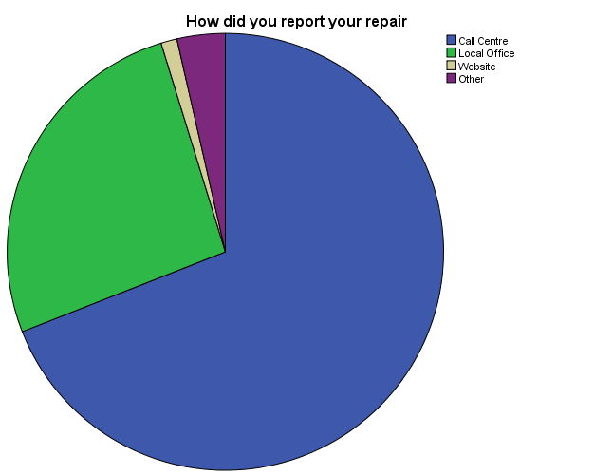
Figure 1 Contacting RRS
From the 84 completed survey results the call centre was the most popular method of contacting the RRS (69%), followed by local office contact (26%) thus underlining that tenants still value face to face contact with RMS staff.
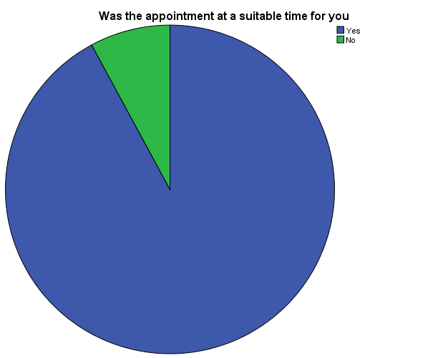
Figure 2. Appointment Times
Tenants also expressed the opinion that the appointment time given at the point of contact was a suitable time, and it transpired that 91% agreed that the appointment was kept. We received many positive comments regarding this aspect of the service from ‘I have no complaints’ or ‘Job done straight away very happy with results’ to ‘The contractor was excellent and did the replacement required promptly and efficiently’ or ‘Everything went well the contractor was very good’. However it is important for CSC staff to work with Tenants to understand the full range of appointment options available. As one Tenant pointed out ‘When are Riverside going to carry out repairs outside of normal working hours, so tenants do not incur loss of income/wages taking time off work’. Of course the Panel understand the logistical implications of this suggestion; still repairs requiring multiple visits do have the potential to impact negatively upon Tenants lives.

If no did Evolve contact you to rearrange?
 | Frequency | Percent
Yes  No  No Answer  Total | 11 | 13.1
 | 18 | 21.4
 | 55 | 65.5
 | 84 | 100.0
Table 1. Evolve Contact
Then again it is within repeat visits that problems appeared to cause further issues for Tenants. Of the 35% of Tenants who required a repeat visit only 13% were contacted by Evolve to rearrange. We found that Tenants in several cases were expected to follow up and ‘chase’ reappointment dates, thus beginning the contact process again. It is within this progression of repeat contact that we found little evidence to track repairs and their progress. This can often lead to complete breakdown in service delivery as this comment explains ‘…such ineffective communication between Riverside and Evolve has meant for the past 3 months I had no bath and issue is still not resolved’. This was a situation which is completely unacceptable, for the Tenant for the Panel and should be a concern for all staff involved.

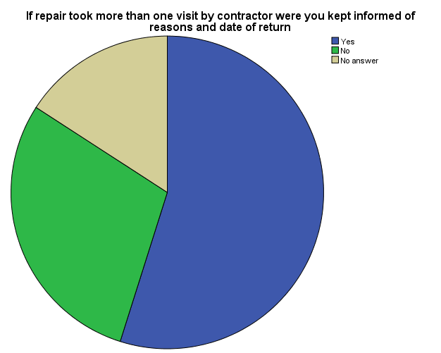
Figure 3. Contractor Updates and Additional Information
28% of these same repeat appointment Tenants were not informed of the reasons and date of return, evidenced with these comments:
‘Kitchen window handle replaced but still needs new fitments to hold window in place, The workman said he would report this problem and return to fix it – as he didn’t have the part, this was three weeks ago’
‘We had a faulty tap upstairs which flooded the kitchen downstairs, it has taken a whole month to get the tap fixed and all the repairs done, how unprofessional your team is…’
We found this to be and indicative component which reflected badly upon the RRS delivery, and undeserved in reference to the many positive experiences Tenants told us about. However it is breakdown in communication which has the ability to lead to these extreme examples, thus undermining the overwhelming satisfaction with RRS set out within Figure 2.
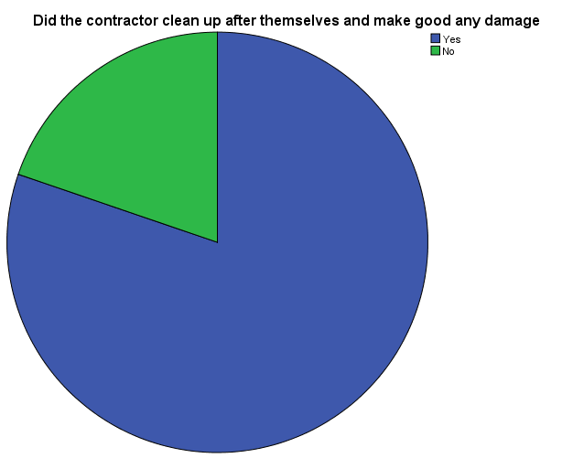
Figure 4. Post Repair Condition
Further we found that 19% of Tenants told us the contractor did not clean up following the repair or made good damage, again this reflects badly upon the overwhelming satisfaction with the RRS.
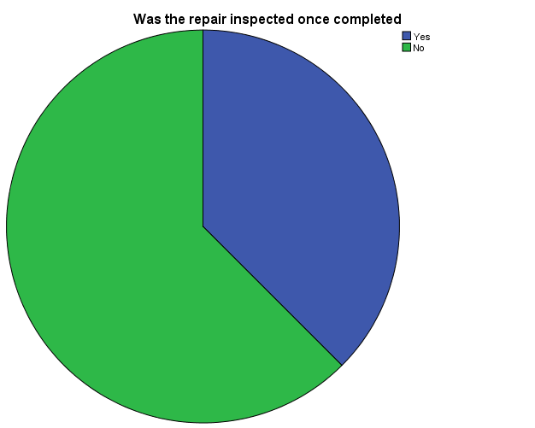
Figure 5 Post Repair Inspection
Finally and more importantly for the former observations regarding inspections, more than half (59%) told us that the repair was not inspected following completion.

4.3.2 Riverside Mersey South Repairs Complaints
We also had access to the complaints data provided by Riverside, we asked for information regarding complaints which were made about the Responsive Repairs Service. The Panel did not look to chart the outcome or status of current complaints, we were more interested in building a picture of what the majority of complaints entailed or why they were being made. Figure 6 below sets out a graph depicting the frequency of complaints and the type of repair and the tradesmen involved, appear.
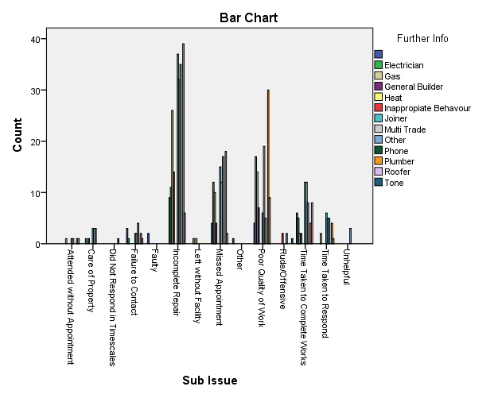
Figure 6. RMS Complaints by Trade
What the Panel found from this table is that the most frequent complaints are levelled at the standard of service delivery. In this way we can infer that repairs which are incomplete, of poor quality (with regards to standards) or no show (missed appointment), are impacting upon the service delivery and underline our own findings with the Panel Tenants Survey above. Similarly the findings allow the Panel to infer that knock on problems could be caused through a lack of appropriate trade craft, for example it appears to us that quality of repair and completion within the ‘multi-trade’ complaints is an issue that requires addressing. There were 209 complaints out 541 (39%) regarding incomplete work, similarly there were 111 (20.6%) complaints against the standard of work completed.
- Interviews with RMS Staff
The Divisional Director intimated that the current repairs service appears to be reactive rather than planned. An overhaul of current systems, policy and procedure is overdue it was suggested and would enhance this service. The panel welcome this and commend the new approach to asset management of the service. The panel were impressed with the potential of the ‘MOT’ approach, where properties are regularly monitored through a checklist designed to be preventive. We view this as a vital way to introduce and influence changes across the service.
We were informed by Riverside and Evolve staff as to how the repair responses are set and progressed; we thank them for making the time to explain this to the Panel. Once a works order has been logged the ownership of it is split between Riverside and Evolve resulting in both parties having incomplete information regarding the progress of logged repairs in addition to Tenant’s needs.
The panel found no evidence of a shared IT system to track a repair in this current system the CSC no longer has the ability to track the details of the repair or progress once passed over to Evolve.
The panel found little or no evidence of post inspections by either Riverside staff or Evolve operatives and this is cause of great concern for the panel. Due to work increased workloads Quality Maintenance Officers (QMOs) are not able to attain the 10% target set for post inspections. The panel were told that in the original agreement Evolve would take over post inspections entirely.
We were informed that Riverside housing managers and Evolve managers meet every six weeks to raise particular issues arising from complaints. This can sometimes affect the time it takes to address and solve problems, as evidence is not forthcoming from post inspections. This delay may lead to further un-necessary works and can cause additional hardship and stress for Tenants. Through the evidence provided it appears that the main issues addressed within these meetings is repairs complaints, usually regarding the standard or quality of contractor repairs, or no show by operatives. We were told that in some cases this is due to vulnerable tenants unable to answer the door for various reasons.

5.1 Personal Digital Assistant Usage and Tracking
During our review of how Evolve track an individual repair through the process, we were told that all Evolve operatives and contractors use a Personal Digital Assistant Device (PDAs). It is possible to send updates and new information on these devices as we found in speaking to other housing organisations, for example LMH. We were told by Evolve and RMS staff that all jobs are signed off upon completion through the devices by tenants. In our own experiences and those of tenants we spoke to we could find no evidence of this taking place and were perplexed as to why this was the case. We asked staff for an update and evidence of the claim; however none has yet been forthcoming.

We were also told by both Riverside and Evolve that cards should be issued to tenants at the completion of a repair for feedback and satisfaction purpose. This is not the case. We found no evidence of this taking place during our review. We have since found this is contrary to procedural guidelines
After meeting with Evolve staff we found that the current use of PDA’s appeared to benefit the contractor and not the tenant, we arrived at this conclusion as we could find no evidence of their use informing service delivery. For example in our Panel Tenants Survey and subsequent interviews we could find no evidence of Tenants being asked to sign a PDA on completion of a repair. This is a pity as we think that the use of PDA devices has the potential to enhance communication between Riverside and Evolve for the benefit of Tenants.
Similarly if utilised to their full potential PDA’s could allow senior staff from RMS and Evolve to gain a bigger picture of what is happening with the repairs service, update tenant profiles and provide useful information to enable better value for money.

6. Riverside Mersey South Responsive Repairs Service Complaints
There were 2500 repairs logged through the Responsive Repairs Service (RRS) during the period we collected our evidence and from those repairs 541 complaints were registered representing around 22% of the total. This appears to be significant, even allowing for multiple calls made by a single complainant; and supports our findings regarding the post inspection procedure. We found little evidence available to show how complaints to the RRS were investigated, what they contained and the mechanisms from which decisions were eventually made. We found that the service has no mechanism in place to record any investigations into the main causes of complaints i.e. Workmanship, materials used, quality of repair and against contractor operatives. We also found no evidence of complaints being discussed in depth at CORE meetings nor indeed as an ongoing agenda updated item.

- Equality and Diversity

7.1 Tailoring Our Service/the Triangle System
Although both systems are in place to highlight or ‘flag up’ vulnerable tenant by visiting operatives, we found no evidence of how this is managed properly. In discussions with staff it is evident that there are failings within the system and there are immediate faults within its design. Visiting staff do carry service consideration and alert warning cards; however, evidence has shown that the same warning Triangle system is not accessible to both RMS and Evolve staff. It is vital that this system should be managed more effectively to ensure all vulnerable tenants receive an appropriate and efficient service. It is also vital that the staff from both RMS and Evolve are protected from potential issues which may arise from this oversight.
- Social Value
Riverside offer an Employment and Training service to tenants, they offer advice on improving employment and training opportunities. The service also seeks ways in which contractors can be encouraged to employ local people, were possible, finding additional opportunities for developing neighbourhoods. We were pleased that Riverside are actively looking for opportunities to engage tenants and families in exploring local employment, training and other options in their neighbourhood.
- Value for Money
The Panel felt that Value for Money (VFM) should be embedded within and across all services Riverside deliver, especially in regards to recent changes to funding and concerns about cost of living outstripping wages. It is sensible, practical and resonates with Tenants that their landlord views VFM as a priority within service delivery. Regular performance reviews and reports should ensure that the service complies with the Homes and Communities regulatory requirements.
The newly implemented Asset Management procedure will hopefully improve the quality of service and give tenants better value for money.
Evolve as ‘in house’ contractor has the potential to offer cost effective service delivery if monitored and managed efficiently, thereby offering better value for money for Tenants in the long term. Indeed we found this approach underlined within the One Riverside Corporate plan (ORCP) 2014-17, as part of the strategy – effective business rationale. However clear wastage and failure to respond to a positive and effective programme of repairs, such as those we found in our results; often end in a failure to provide value for money for Tenants.
We welcome and look forward to the fresh outputs and outcomes following the roll out from the Asset Management Team’s new service. This should go some way in offering Riverside much needed cost saving by this innovative approach. Again this approach is set out within the ORCP within the connected customer’s rationale, where it is stated ‘we need to be better at getting our repairs service right first time’.

- Conclusions.
On first reading the findings set out within this review appears to be challenging, yet we hope RMS take on board that we have been thorough in our collating our evidence. The Panel found practices, which in our opinion have become inept if RMS wishes to deliver the best for its Tenants. Similarly the Panel understand recent changes covering many aspects as to how RMS delivers the Responsive Repairs Service affects current statistics. The changes to the revised complaints procedure set out within the RMS Divisional Board meeting (17th July 14: 6.5) affects the data in this way. We are also aware that it may take time to successfully introduce innovative new approaches to service delivery, for example the MOT approach. In this way it is vital that from their inception Riverside have a system in place which not only records and tracks repairs, but is also able to share information with contractors.
Key themes appeared when problems were apparent, these included lack of communication, issues of quality and a perception of problems appointment system. The panel are aware that the ratio of completed repairs to complaints may not be an immediate cause for concern; nonetheless there are issues which in our opinion can be addressed through monitoring the delivery of service more closely. Indeed there is evidence within the aforementioned document that backs our concerns regarding Evolve ‘buying into’ statistical collation to inform service (RMS Divisional Board meeting, 17th July 14: 3.2).
It is the Panel’s findings within this document which lead us as a group to make the recommendations found within the following section. We hope that these are taken on board if not fully addressed in the way that our limited technical knowledge may suggest. In spite of this we would hope that Senior Management recognise that although we may not be able to comprehend the innate problems indicative of a service of this size, it would be remiss of the Panel not to raise the points set out within.

- Recommendations

- KPI’s for responsive repairs should be a ‘stand-alone’ target and not included as part of First Time Fix. This should go some ways in to revealing a true picture of service performance.
- Policy and Procedures to be reviewed and updated immediately
- Review of how quality management information is effectively captured, measured and evaluated.
- The use of Personal Data Assistant (PDA’s) to be reviewed, revamped and monitored. By this we believe that PDAs and their usage should be embedded into how operatives sign off on repairs, visits and appraise repairs and the quality of work. In turn this has the potential to inform and improve the delivery of the service for both Evolve and the Riverside Group. Also adding additionality to the service by improving communication, tracking the progress of repairs and operatives.
- The panel recommends that a joint tracking system be put into place to insure the progression of a reported repair can be followed through from initial report to completion by Riverside and evolve staff and tenants. We welcome the proposed Ivolve system to address this problem and look forward to further information.
- A more robust procedure for post inspection needs to be developed in order to lessen the number of complaints and therefore increase value for money.
- Levels of complaints should be an agenda item at all CORE meetings to be discussed at senior management level to highlight and address the main problems set out within this review. CORE meetings involve Riverside Divisional Director, Riverside Senior Management and Evolve Senior Management.
- The Panel also feel that this is a good opportunity for Riverside to pioneer a 21st century approach to the introduction of a tenant trained forum group to follow post inspection procedures to limit the number of complaints.
- Review “Triangle” system with immediate effect ensuring continuity of appropriate system for both Riverside and Evolve Staff

11.1 Recommendations for National Consideration

- Tenant Panel to be piloted to follow the quality of post inspections
- Standardized service level and agreement to be rolled out across the Riverside Group and signed up to by all contractors.
- Tenancy new tenancy packs to include booklets comprehensively detailing and explaining the procedure for repairs and what tenants can expect.

References

Complaints Analysis Report
Complaints Statistics
Internal Standards Best Practice / Housemark Policy
KPIs
One Riverside: Corporate Plan 2014-17, (The Riverside Group Limited).
Report to the Divisional Board
Riverside: Maintenance Policy (Ref: 15) (Jane Keegan/ John Hayes)
Report to the Riverside Mersey South Divisional Board Meeting, Thursday, 17th July 2014, (Kerry Howard & Peter Yoh).
Riverside: Responsive Repairs Procedural Document, (Jane Keegan).
STAR report

All returned questionnaires will be entered into a prize draw to win a £50 High street voucher

Appendices
Appendix 1.
Tenant Repair Questionnaire
You have recently had a repair carried out at your property by Riversides contractor, Evolve. We as the tenant’s Scrutiny Panel for the Mersey South division are evaluating the repairs service on your behalf. If you could complete this short questionnaire and return it in the stamp addressed envelope it would be much appreciated. Alternatively you can fill in the online version by visiting: www.riverside.org.uk/repair_questionnaire.aspx

- How did you report your repair? (Please tick Appropriate box)
Call Centre Local Office Website Other

- Where you given an appointment?
Yes No

Was the appointment at a suitable time for you?
Yes No

- Was the appointment kept?
Yes No

If No did Evolve contact you to re-arrange?
Yes No
- If the repair took more than one visit by the contractor were you kept informed of the reasons why and when they would return?
Yes No

- Did the contractor clean up after themselves and make good any damage to décor, etc?
Yes No

If no what could they have improved on?

- Was the repair inspected once completed?
Yes No

- Where your individual needs met? (e.g. knock loudly)
Yes No

- Any additional comments / suggested regarding your repair

Thank you for taking the time to complete this questionnaire.
Members of the Scrutiny Panel may contact you to ask additional questions. If you would prefer not to be contacted please tick the box

To be entered into the prize draw to win £50 of high street vouchers please provide your contact details:

Name: ___________________________________________________

Address: _________________________________________________

Contact Tel No: ____________________________________________

Please return the completed questionnaire in the pre-paid envelope no later than Monday 15th December 2014

If you are interested in being involved with Riverside, in particularly on the scrutiny panel or mystery shopping please contact Jackie Ulring on 0345 111 0000 or Jacqueline.ulring@riverside.org.uk

Personal Digital Assistants (PDAs) A lightweight handheld digital device for managing personal information, often capable of performing other functions such as word processing, voice recording, interacting with personal computers, and accessing the Internet.

