Minutes of the RCVE Meeting 12/10/2023

Teams (10:30 – 15:00)
Attendees:

RCVE: Vic Andrews, Paula Simpson, David Otty, Carole Warburton
Keith Harkness, Viv Fleming, Jonothon Laycock

Riverside: Chris Colman, Jo Young, Steve Hewitt, Gina Birkenhead,
Rebecca Gorman, Charlene Little, Andrea Thorn, Robert Frier, Hugh Owen,
Emily Pumford, Paul Kershaw, Joanne Scarlett, Rajvinder Vine

1 | Welcome and Introductions  VA opened the meeting and thanked all for attending today’s session.
2 | Apologies | Sarah Wall, Patrick New, Lee Buss Blair, Elaine Bateson
3 | Previous Minutes | Minutes from previous meeting on 17/08/2023 were agreed.
4 | Matters Arising | Pet Policy - AT to chase up as disappointed this has still not been received. AT was told that this was with the legal depart to complete final read around to ensure nothing would breach any legal requirements. The policy is done and all feedback and suggestions from RCVE has been incorporated. Just waiting final approval.  VA enquired if the RCVE would have site of policy to check before it goes ahead. AT informed all that it is not a policy, it is a procedure and as such final sign off with the RCVE will be made.  Convene – Update from CC. Cost stands at £100 pp per year at present but is due to be reviewed and may rise to approx. £120. VA confirmed an email had been sent to members and all agreed this was a good idea. RCVE are happy for this to go ahead. CC to go back to Mark Ferguson to get things rolling.
5 | Finance Update  Steven Hewitt | SH advised that account balance as of 12/10/2023 was £44,862.29.  SH confirmed that the accounts for year ending 31/3/23 are now complete. A hard copy will then be sent to VA and one other officer.  Amount recovered by Riverside was £26,961.  Balance after recovery was £50,00 and approximately £5,00 has been spent since 1/4/23.
6 | Reports  Robert Friar  C&S Update | Reports have all been circulated prior to the meeting except Care and Support report which once again has not been received. VA confirmed that EB has chased this but still not been received from them.  VA stated that it is important that these are received in a timely manner for the RCVE to efficiently complete their duties.  VA talked about recent scheme visits in the Southport areas and expressed concern about complaints policies not being visible on notice boards etc. We know complaints are a big issue – suite sad that the appeals processes were unfamiliar to them. VA would like some assurance that fundamental knowledge is being shared with front line workers, so they know procedures.  RF shared VA’s feelings and confirmed that managers should be fully inducted on complaints procedures.
7 | New RCVE Officer Appointments | VA confirmed that at present only he and PS are now officers. VA has sent out an email asking of any interest to take on roles within the RCVE. Some responses have been received. VA requested that if anybody able to step up to please contact himself or EB as soon as possible. He also reiterated that this does not necessarily have to be a long-term commitment as elections will take place in April 2024 – volunteers will not be tied to these roles if they only wish to take on a position temporarily.  The filling of these roles is ongoing while waiting for any further replies. VA emphasized that he hoped to fill these roles this week and stated that if duplicate applications are received then a vote will be required.  DO – asked if everyone at the meeting was aware of Margi and Rich resigning. VA felt this had been made clear in the email sent out for recruitment. DO expressed that it was a shock that they were no longer members. VA said that both Margi and Rich felt they had come to the point where they do not wish to be further involved.  At this point VA took the opportunity to thank both Margi and Rich for their tireless work during their time with the RCVE.  Margi – works practically every day within the community. She has always worked hard for the good of customers and the neighbourhood. She will be missed.  Rich – he has always brought a very level and sensible head to the RCVE and as secretary he completed his work effectively.  VA thanked both on everybody’s behalf. Their input will be greatly missed. AT reminded caution around conversation on this subject.
7a | Co-opted Member | VA recommended that JL, who has attended several meetings as an observer, will be co-opted on to the RCVE. VA asked if everyone is in favour – all agreed with no opposition.  VA welcomed JL.  JL thanked everybody and promised to do his best.
8 | Retrofit Inspectors  Chris Collman | CC spoke about Chris O’Shea’s recent presentation a the last bi-monthly meeting in August. CC discussed the involvement of RCVE in handovers.  4 areas to be covered:  Carlisle (169 homes) Halton (301) Liverpool (415) London (139)  CC asked if any members living close to these areas would like to be involved. He emphasized that short notice visits may be required, and safety briefings will be completed on site – these would be site specific.  Looking to design a short questionnaire regarding handovers. CC suggested meeting with RCVE to discuss possible questions to be included. CC explained that they want to trial this with RCVE members, but it will be an ongoing project over the next couple of years.  CC to work closely with Chris O’Shea and RCVE members.  Volunteers to contact CC directly by email. SH to meet with KH to keep him up to date.  VA felt this was a good idea and all agreed. VA thanked CC for update.
9 | CI&E Strategy Update  Charlene Little | CL shared presentation on current updates. The presentation was circulated to attendees prior to the meeting.  CW – enquired about why people’s details are asked for twice when contacting the call centre. CL to investigate this.  DO – felt that the work being completed was really good, but he felt that we need to prove this so that people know it means something. He thanked CL.  CL confirmed that feeding back is a crucial part of the strategy. When customers are involved, they can ask to be kept informed of local plan; the ‘local offer’.  VA also reiterated that customers are interested in results and outcomes, but this will take time to reconnect with local voice.
 | Comfort Break
10 | Scrutiny Update  Rajvinder Vine | ASB update shared on the action plan to show where they are up to. PowerPoint presentation shared.  PS – commented on how a positive impact has been made and thanked RV.  VA – we need to ensure that the message has gone out to customers about the difference customer involvement has made. Always take the opportunity to share success and good practice.  Next Scrutiny topic to be decided as soon as possible. 3 Possible choices:  - Damp & Mould  - Building Safety (High rise communication plan)  - ED&I  VA felt there was a possibility that they may fit 2 in.  VA asked if anybody who is interested in being involved could please email him.
11 | Responsive Repairs  Paul Kershaw & Joanne Scarlett | JS talked about rechargeable repairs whilst PK shared presentation.  JS explained that the process is very out of date; over 11 years old and the proposal is to bring this up to date.  PK looked at ‘Current Sector Best Practice’ and talked about the understanding of best practice and how this can be incorporated.  Questions – what next? RCVE feedback very important.  JL asked if this was a revenue raising exercise. JS explained that money raised will be put back into repair; what is recovered does not cover what is spent. She felt that they would not recover all costs. Riverside are not interested in raising an income; its about reletting homes in a better condition.  JL asked if the admin fee will be limited to the actual cost of administration. JS answered that this needs to be worked out and there is a need for transparency. This will be communicated in the policy.  JL asked if this is covered by the tenancy agreement and AT shared that it is a standard clause in every tenancy agreement; it may be worded differently but it will be in every agreement.  PS shared that customers who are leaving properties in this condition will not be able to repay debts. She felt it may work in shared ownership but not in social housing.  AT agreed - as there may be other debts we need to minimise repairs needed. However, these costs are going on to other tenants. This is unfair and we have a duty to all tenants.  JS reiterated that a simple consistent policy needs to be put in place.  DO agreed with PS. He felt it would be difficult to track a tenant once they have left in order to recover costs. He felt that tenants wont always report damage as they may have caused the damage themselves. JS confirmed that extreme cases can be reported (e.g., due to safeguarding concerns.  CW asked how soon costs would need to be paid by the customer. JS said that this would be between 30 and 60 days depending on the situation of the contractor.  JL asked who will be making the decisions and who will operate the policy. JS – various teams would be involved on a case-by-case basis.  The question was raised about what would happen if recovering the costs is more than the cost of the actual repairs and JS said this would have to be reviewed. AT stated that it is a requirement in regulatory standards to have a rechargeable repairs policy. But we need a policy that might deliver results rather than costing people money; we need to protect customers as best we can/  AT talked about the vulnerability comment – if a customer has just 3 weeks to complete repairs, then Riverside can provide support. There would be an opportunity for a housing manager to speak to AT and put forward a case as to why it is not appropriate to charge these customers and AT can write the debt off. There are fail safes to protect vulnerable customers.  PS suggested that when communicating to customers she would strongly recommend using the term ‘negotiate’ a fee because customers will be more inclined to engage with that.  JS thanked everybody for their feedback.  VA reiterated what everyone had discussed – whatever route is taken, Riverside need a policy as simple as possible that is easy to understand and communicate. He felt we need a better system that is more robust. He felt that evidence is needed at every stage to show the condition that the property was let at the beginning of the tenancy.  There was further clarification about what a flat rate was.  JL felt the admin fee needed stripping away but felt that the charge should be accurate to full cost recovery rather than a flat rate.  JS said that the business accepted that full cost recovery is unlikely.  VA thanked JS and PK for their presentation.
 | LUNCH
12 | Assessment Day | Date to be fixed for the end of November. VA confirmed that this was urgent so we can get back to a pre-Covid status.  VA enquired about AT’s thoughts on ideas for the day and have these been incorporated into the plans for the day. AT shared that more discussion was needed.  There was a brief discussion regarding an independent panel of customers making the decision as to who can serve on the RCVE.
13 | AGM Update | EB has sent notification about where and when this will take place and VA asked if everybody had received these. EB to forward details to our newly co-opted member JL.  VA confirmed that the agenda would be set shortly, and this will be forwarded to all involved. He informed everybody that it may possibly include changes to the constitution, but these would be subject to a discussion that has not yet taken place.  AT confirmed that the only thing being worked on from an officer’s perspective is the consultation with customers on the amendment to the clause around the tenant complaint panel.  Notification of changes will be sent out in good time so a vote can be taken to make changes official.
14 | Minibus | VA – at present use of the minibus is minimal. There is a need to look at what is needed to get it functional. Decisions need to be made on how to make it a useful asset. Considerations:  - Disability lift is not working.  - Problems with license to drive it.  - Not Ulez compliant.  Possible ideas:  CL felt it might be easier to service etc. if it was based at Speke.  Should it be sold and bring asset back into the account?  Could it be used elsewhere by Riverside on a worthwhile cause such as ex-service scheme?  JL asked who owned and VA confirmed it was owned by the RCVE.  It was agreed that further discussion was needed about a long-term plan.
15 | Rent Review Policy  Hugh Owen & Emily Pumford | HO confirmed that a second consultation has been scheduled for the 2^{nd of} November. Today is to introduce the issues to give RCVE time to look at issues before then to enable further discussion.  EP shared presentation. Six questions were presented at the end.  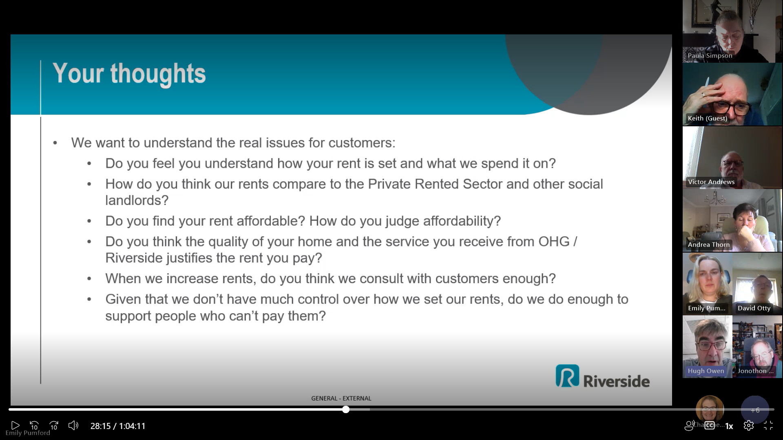  PS feels that Riverside are in a good position for reviewing rents as Private rents are so high at present; now is the time to introduce rent increases. She also felt that communication about rent increases is critical at the moment.  HO agreed this was a really good point but felt that we cannot be complacent. We should be mindful of still doing the right thing.  HO also felt that we should communicate to customers how our rents compare favourably with Private rentals and how we can further support tenants.  KH felt rent is very fair; but service/repairs etc let Riverside down. To avoid complaints, customers need more information on why their rent has been increased.  DO made a point about helping people who cannot pay; trying to get to people earlier and not leaving it too long to address arrears is the sensible way forward. He felt we need to be noticing when people might need help; early intervention is very important.  AT shared that data source runs analytics and recognises changes in patterns that early intervention officers can work with. Push outs are also done by text and auto letters are sent.  JL was concerned that is no way of challenging rent increases without going to a tribunal. HO agreed that challenge for the customer is limited.  VA then answered some of the questions addressed (as shown above)  - RCVE may have some understanding because they are involved in the process but other customers understanding may be limited.  - VA felt that rent is certainly lower that private sector but would not advocate this as an opportunity to raise rents as high as possible. HO shared slide to show we are comparable with other housing sectors.  - Affordability comes down to what your income is. Any increase will have more of an effect than a few years ago and we need to be mindful of this.  - In most case Riverside try to keep their homes up to a standard and for the rent charged then the service is good.  - White paper has told us that we need to show we consult more widely and that is already being worked through Customer National Framework. If this works well this will be evidenced. HO felt that ability to consult is somewhat constrained but confirmed that Riverside would consult as much as they can do.  Ho thanked everybody for their time and explained that in readiness for the November consultation they would be putting together a one-page outline to bullet point the essence of a new policy,
14 | AOB | None noted
 | Meeting ended at 3.00pm

Appendix 1
No. | Description |  | Owner(s) |  | Deadline |  | Status | Notes
1 | Pet policy |  | Riverside |  | Next meeting |  | In progress | Awaiting formal approval
2
3
4
5
6
7 | IT Issues with email |  | RN/CC |  | Not set |  | Ongoing | Waiting on any potential issues with "Convene"
8 | Earlier production of RCVE minutes |  | RN/CC |  | Complete |  | Agreed | Last minutes sent out & agreed within 2 weeks of meeting date
9 | Digital roadmap assistance |  | SW |  | Not set |  | No update yet
10 | Damp & Mould e-learning roll-out |  | LP |  | Not set |  | Complete
11 | Void item retention |  | PN |  | See action 12 |  | Complete
12 | Void item retention |  | AT/SW |  | Not set |  | In progress | Prep complete, go live Mon 26 June for 3-month validation

